**PAPER – II         PRACTICAL NO. : 05**

**AIM : OBSERVE STP PROTOCOL CHANGES AND IMPLEMENT RSTP**

**1.IMPLEMENT ADVANCED STP MODIFICATIONS AND MECHANISMS**

**2.IMPLEMENT MST**

**ROLL NO. : 02                                BATCH : M.SC PART-I**

**DATE : 07/12/22**

**CODE AND OUTPUT :**

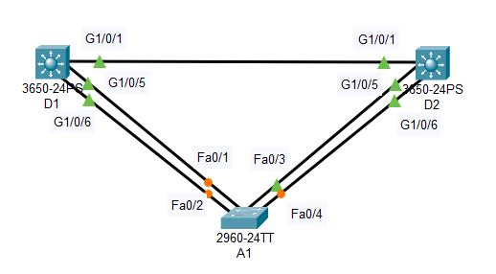

A1 :

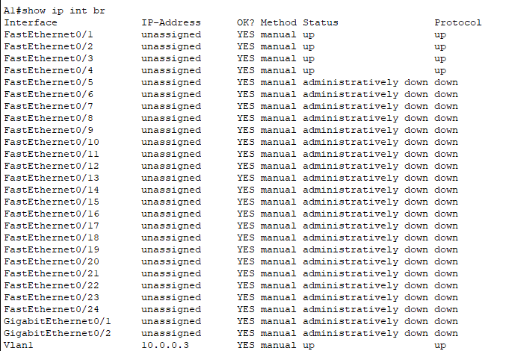

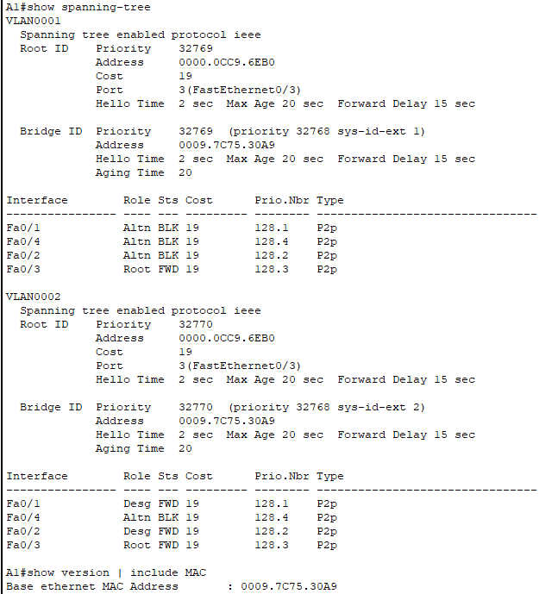

D1 :

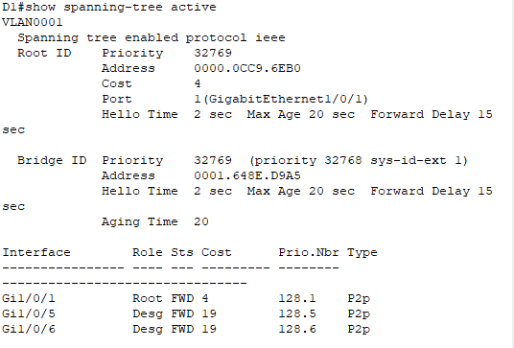

D2 :

